**Installation Guide:**

1. Create a folder titled “lib” in the Java project. Add the .jar files from Blackboard into the folder.
2. Right click on the project name in the left sidebar in Eclipse. Go to Build Path > Configure Build Path.
3. Select Add External JARs on the right. When the new window appears select the JAR files in the lib folder. Click OK.
4. Run the program. It will create and populate any tables necessary.

**Instructions:**

See All Students: Click Display Students.

Add Grade: Fill in the student name, new assignment name, and grade. Click Add Grade.

Modify Grade: Fill in the student name, assignment name, assignment ID, and the new grade. Click Modify Grade.

See All Grades: Fill in the name of the student whose grades you would like to see. Click Display Grades to show all of that student’s grades.

**UML**

**Screenshots**

Display students: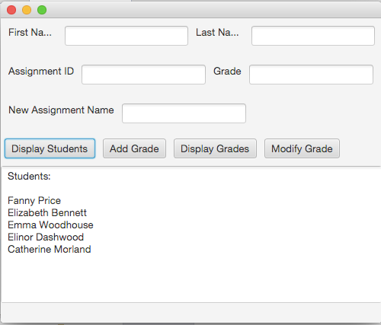

Add Grade: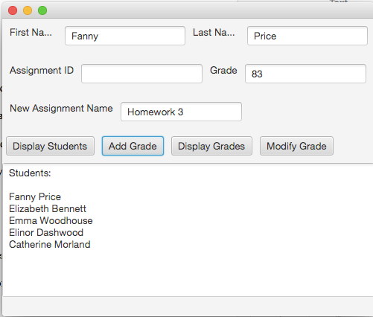

Display new grade:

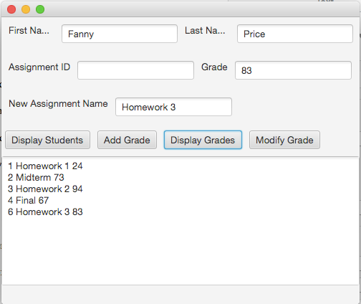

Show modified grade: